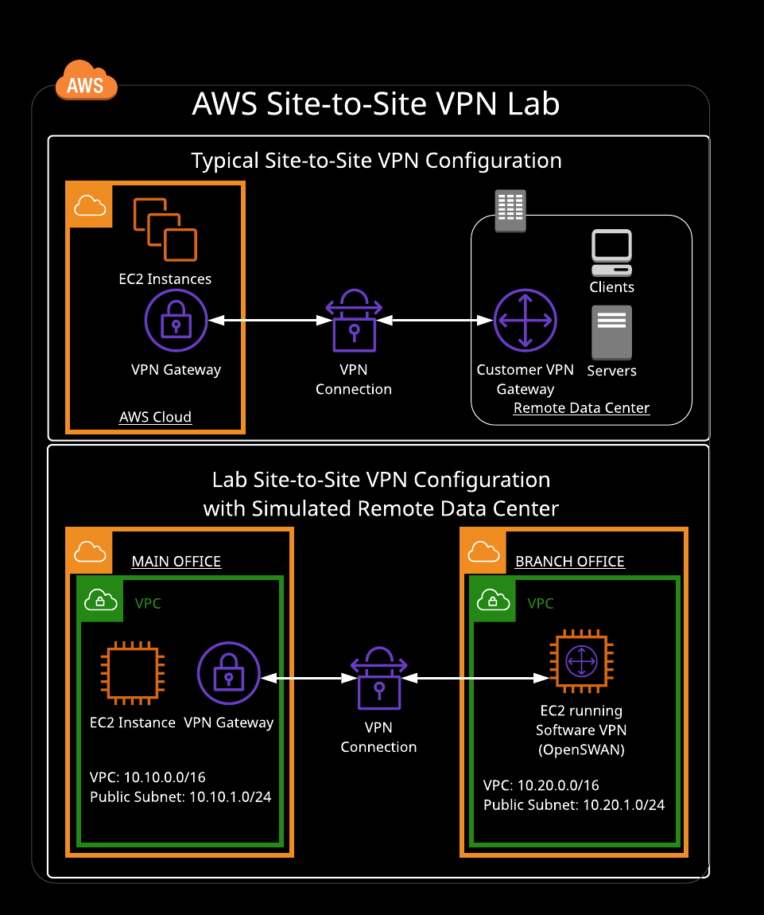
Additional Information and Resources
The main office of your organization has completed their migration to the AWS Cloud, but a branch office is still using a private, remote data center. You need to configure a secure Site-to-Site VPN connection that will allow branch office servers to connect to data stored in the main office VPC in the AWS Cloud. The connection must be secure and use the internet connection already existing in the branch office data center.
The main office VPC has been created for you. The branch office remote datacenter will be simulated by using a second, separate AWS VPC in a different Availability Zone, which has also already been created for you.
You need to create an EC2 instance in each VPC, create a customer gateway, virtual private gateway, and Site-to-Site VPN connection in the main office VPC. You then need to install and configure OpenSWAN on the EC2 instance in the branch office VPC to function as the remote data center's software-based VPN. You'll also test connectivity by pinging each EC2 instance.

Creating an AWS Site-to-Site VPN

Introduction
In this lab, we'll create an AWS Site-to-Site VPN connection from an AWS VPC used by our organization's main office to a private, remote data center used by a branch office. We will simulate the branch office network via a second AWS VPC, installing and configuring a software-based customer VPN gateway running on an EC2 instance. We'll also create a virtual gateway and configure the Site-to-Site VPN to use a secure IPsec tunnel between sites. We will then test connectivity.

Solution
Log in to the live AWS environment using the credentials provided. Make sure you're in the N. Virginia (us-east-1) region throughout the lab.
Note: When copying and pasting code into Vim from the lab guide, first enter :set paste (and then i to enter insert mode) to avoid adding unnecessary spaces and hashes.

Verify Resources and Examine Network Configuration
- Navigate to VPC > Your VPCs, and verify there are currently two VPCs in different Availability Zones:
  - VPC-MainOffice with CIDR block 10.10.0.0/16
  - VPC-BranchOffice with CIDR block 10.20.0.0/16
- Click Subnets in the left-hand menu, and verify there's a public subnet in each VPC:
  - Subnet-MainOffice-Public with CIDR block 10.10.1.0/24
  - Subnet-BranchOffice-Public with CIDR block 10.20.1.0/24
- Click Internet Gateways in the left-hand menu, and verify there's an internet gateway (IGW) in each VPC.
- Click Route Tables in the left-hand menu.
- Verify there are two route tables, each attached to the appropriate subnet (which you can find by clicking the Routes tab on the page):
  - Names: RT-MainOffice and RT-BranchOffice
  - Routes: Local, and 0.0.0.0/0 pointing to the IGW

Create Two EC2 Instances
Create two new EC2 instances: one in VPC-MainOffice and one in VPC-BranchOffice.

EC2-MainOffice
- Navigate to EC2 > Instances, and click Launch Instance.
- On the AMI page, select the Amazon Linux 2 AMI.
- For instance type, choose t2.medium.
- Click Next: Configure Instance Details.
- On the Configure Instance Details page:
  - Network: VPC-MainOffice
  - Subnet: Subnet-MainOffice-Public
  - Auto-assign Public IP: Enable
- Click Next: Add Storage, and then click Next: Add Tags.
- On the Add Tags page, add the following tag:
  - Key: Name
  - Value: EC2-MainOffice
- Click Next: Configure Security Group.
- Select to Create a new security group.
- Give it the Security group name of SG-MainOffice.
- Give it the Description of SG Main Office.
- For the default rule listed, change its Source to My IP.
- Click Add Rule:
  - Type: All TCP
  - Source: Custom, 10.20.0.0/16
- Click Add Rule:
  - Type: All UDP
  - Source: Custom, 10.20.0.0/16
- Click Add Rule:
  - Type: All ICMP - IPv4
  - Source: Custom, 10.20.0 0/16
- Click Review and Launch, and then Launch.
- In the key pair dialog, select Create a new key pair.
- Give it a Key pair name of Key-MainOffice.
- Click Download Key Pair, and then Launch Instances.
- Click View Instances.

EC2-BranchOffice
- On the instances dashboard, click Launch Instance.
- On the AMI page, select the Amazon Linux 2 AMI.
- For instance type, choose t2.medium.
- Click Next: Configure Instance Details.
- On the Configure Instance Details page:
  - Network: VPC-BranchOffice
  - Subnet: Subnet-BranchOffice-Public
  - Auto-assign Public IP: Enable
- Click Next: Add Storage, and then click Next: Add Tags.
- On the Add Tags page, add the following tag:
  - Key: Name
  - Value: EC2-BranchOffice
- Click Next: Configure Security Group.
- Select Create a new security group.
- Give it the Security group name of SG-BranchOffice.
- Give it the Description of SG Branch Office.
- For the default rule listed, change its Source to My IP.
- Click Add Rule:
  - Type: All TCP
  - Source: Custom, 10.10.0.0/16
- Click Add Rule:
  - Type: All UDP
  - Source: Custom, 10.10.0.0/16
- Click Add Rule:
  - Type: All ICMP - IPv4
  - Source: Custom, 10.10.0.0/16
- Click Review and Launch, and then Launch.
- In the key pair dialog, select Create a new key pair.
- Give it a Key pair name of Key-BranchOffice.
- Click Download Key Pair, and then Launch Instances.
- Click View Instances, and give it a few minutes to enter the running state.
- Once EC2-BranchOffice enters the running state, select it.
- Copy its public IP address, and paste it into a text file, as we'll need it shortly.
- With EC2-BranchOffice still selected, click Actions > Networking > Change Source/Dest. Check.
- In the dialog, click Yes, Disable.

Create Virtual Private Network Resources
- Navigate to VPC > Virtual Private Gateways.
- Click Create Virtual Private Gateway.
- Give it a Name tag of VPG-MainBranch.
- Click Create Virtual Private Gateway.
- With it selected, click Actions > Attach to VPC.
- In the VPC dropdown, select VPC-MainOffice.
- Click Yes, Attach.
- Click Customer Gateways in the left-hand menu.
- Click Create Customer Gateway, and set the following values:
  - Name: CGW-MainBranch
  - Routing: Static
  - IP Address: Public IP address of EC2-BranchOffice (that you copied a minute ago)
- Click Create Customer Gateway.
- Click Site-to-Site VPN Connections in the left-hand menu.
- Click Create VPN Connection, and set the following values:
  - Name: VPN-MainBranch
  - Target Gateway Type: Virtual Private Gateway
  - Virtual Private Gateway: VPG-MainBranch
  - Customer Gateway: Existing
  - Customer Gateway ID: CGW-MainBranch
  - Routing Options: Static
  - Static IP Prefixes: 10.20.0.0/16
- Click Create VPN Connection. It may up to 10 minutes to enter the available state.
- Once it's available, click Download Configuration.
- In the dialog, set Vendor to Generic.
- Click Download.
- Open the downloaded configuration text file.
- In the Internet Key Exchange Configuration section, note the Pre-Shared Key, as we'll need it shortly.
- In the Tunnel Interface Configuration section, note the listed outside IP address for our customer gateway and virtual private gateway, as we'll need them shortly as well.
- Leave the downloaded configuration text file open so we can copy and paste those values in a minute.

Install and Configure Openswan
- Back in the EC2 Dashboard, select our EC2-BranchOffice, then click the Connect button up above it. There will be a window that pops up with connection information. Copy the Public DNS.
- Open a terminal on your own computer, change to the Downloads directory (with cd Downloads), and change the permissions on our key pair file:
chmod 400 Key-BranchOffice.pem
- Now log in, with SSH, using that key pair file and Public DNS with this:
ssh -i "Key-BranchOffice.pem" ec2-user@<Public DNS>
Just be sure to replace Public DNS with what we saw in that pop up window.
- Become root:
sudo su
- Install Openswan:
yum install openswan
- Enter y at the prompt.
- Open /etc/ipsec.conf:
vim /etc/ipsec.conf
- If there is a # in front of this line, remove it:
include /etc/ipsec.d/*.conf
If not, exit the file by entering :q. (If you had to delete #, save and exit the file by pressing Escape followed by wq!.)
- Open /etc/sysctl.conf:
vim /etc/sysctl.conf
- Add these lines to the bottom of the file:
net.ipv4.ip_forward = 1
net.ipv4.conf.default.rp_filter = 0
net.ipv4.conf.default.accept_source_route = 0
Save and exit by pressing Escape followed by wq!.
- Open /etc/ipsec.d/aws.conf:
vim /etc/ipsec.d/aws.conf
- Add these lines to the file:
conn Tunnel1
authby=secret
auto=start
left=%defaultroute
leftid=<CUSTOMER_GATEWAY_OUTSIDE_IP_FROM_CONFIGURATION_FILE>
right=<VIRTUAL_PRIVATE_GATEWAY_OUTSIDE_IP_FROM_CONFIGURATION_FILE>
type=tunnel
ikelifetime=8h
keylife=1h
phase2alg=aes128-sha1;modp1024
ike=aes128-sha1;modp1024
keyingtries=%forever
keyexchange=ike
leftsubnet=10.20.0.0/16
rightsubnet=10.10.0.0/16
dpddelay=10
dpdtimeout=30
dpdaction=restart_by_peer
Make sure to change the leftid and right lines so that the correct IPs follow the equals signs. Save and exit by pressing Escape followed by wq!.
- Open /etc/ipsec.d/aws.secrets:
vim /etc/ipsec.d/aws.secrets
- Enter the following, using the values found in the configuration file:
<CUSTOMER_GATEWAY_IP_ADDRESS> <VIRTUAL_PRIVATE_GATEWAY_IP_ADDRESS>: PSK "<PRE_SHARED_KEY>"
- Restart the network service:
service network restart
- Set the ipsec service to run automatically if the server restarts:
chkconfig ipsec on
- Start the ipsec service:
service ipsec start
- Check the status of the ipsec service:
service ipsec status
- In the AWS console, navigate to VPC > Route Tables.
- Select RT-MainOffice.
- Click the Route Propagation tab.
- Click Edit route propagation.
- Select the Propagate checkbox next to VPG-MainBranch.
- Click Save.
- Click Site-to-Site VPN Connections in the left-hand menu.
- Click the Tunnel Details tab. It may about five minutes or so for the Status of Tunnel 1 to change from DOWN to UP. Click the refresh icon on the page after a few minutes to make sure it changes to UP.

Test Connectivity Across VPN
- Navigate to EC2 > Instances.
- In the terminal, we should still be connected to EC2-BranchOffice. If not, connect like we did earlier.
- Attempt to ping EC2-MainOffice using its private IP address (which can be found on the instances page):
ping <EC2-MainOffice_PRIVATE_IP_ADDRESS>
We should be successful.
- Cancel the ping by pressing Ctrl+C.
- Log out of EC2-BranchOffice by entering exit twice.
- If you aren't already in it, change to your downloads directory (e.g., cd Downloads).
- Change the permissions on your Key-MainOffice.pem key pair file:
chmod 400 Key-MainOffice.pem
- In the AWS console, select EC2-MainOffice.
- Click Connect.
- Copy the listed ssh string.
- Paste the ssh string into the terminal.
- In the AWS console, select EC2-MainOffice.
- Click Connect.
- Copy the listed ssh string.
- In the terminal, paste the ssh string to connect to EC2-MainOffice.
- Attempt to ping EC2-BranchOffice using its private IP address (which can be found on the instances page):
ping <EC2-BranchOffice_PRIVATE_IP_ADDRESS>
We should be successful.
- Cancel the ping by pressing Ctrl+C.

Conclusion
Congratulations on successfully completing this hands-on lab!

